Chapter 9 random

Here is my code 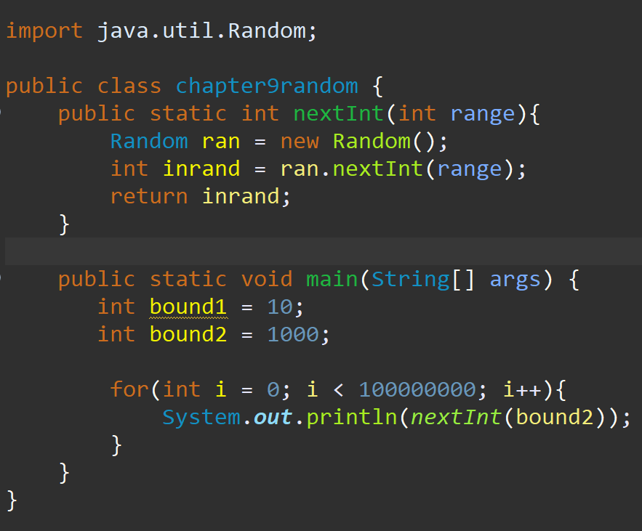

Here is my charts

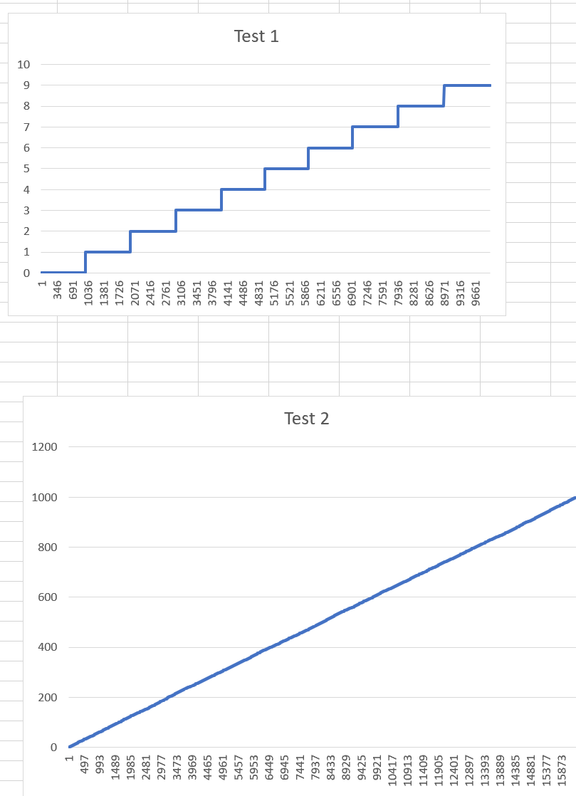the distribution at first looks pretty even in the second chart it is hard to see since the range is so far apart but it is moving show how many times 0-999 repeats.

if we are speaking in it has to be exact terms then yes some numbers were statically more proven to pop up then others. in my example for the second test 0 popped up 25 time and 1 popped up 20 times so although it is pretty close 1 was more often meaning that statically random number is exactly repeating at what it should be some number have more of a chance.